Margarita Geleta, Ibrar Malik

Mathematical Optimization | Data Science

Pattern Recognition

WITH SINGLE LAYER NEURAL NETWORKs

We define it in *Python* as follows:

|  |
| --- |
| **def** **sigmoid**(x):  **return** 1. / (1. + np.exp(-x))  **def** **y**(X, w):  **return** **sigmoid**((**sigmoid**(X) @  w.T)) |

**Network training**

Now the big question is: how do we get our neural network to learn? It is going to learn from errors. Thus, we need to define an “*error/loss function*”. Before formulating that function, note that we are going to use a set of numbers to train our network and a separate test for testing the predictions. These sets are called *training ($X^{TR},y^{TR}$)* and *test* ($X^{TE},y^{TE}$) sets, respectively.

The loss function is defined as follows:

$$L\left(X^{TR},y^{TR} \right)=\sum_{j=1}^{p}{{\left(y\left(x_{j}^{TR},w\right)-y_{j}^{TR}\right)}^{2}}$$

being $p$ the size of the training set. We can also add a regularization parameter $λ$ (of type *L2*):

$$\tilde{L}\left(X^{TR},y^{TR} \right)=L\left(X^{TR},y^{TR} \right)+λ∙\frac{{\left\|w\right\|}^{2}}{2}$$

We define them in *Python* in one method. If $λ$ = $0$, then we return $L\left(X^{TR},y^{TR} \right)$, otherwise we return $\tilde{L}\left(X^{TR},y^{TR} \right)$ with its corresponding regularization parameter $λ$:

|  |
| --- |
| **def** **loss**($w$, $X^{TR}$, $y^{TR}$, $λ$ =0):  **return** np.linalg.norm(y($X^{TR}$, $w$)  – $y^{TR}$)**2 + $λ$/2 *  np.linalg.norm($w$)**2 |

To train the network, i.e. find the optimum $w$, we need to minimize $L\left(X^{TR},y^{TR} \right)$ with some optimization algorithm. To minimize the loss function, we need its gradient:

$$\frac{∂\tilde{L}\left(X^{TR},y^{TR} \right)}{∂w_{i}}=\sum_{j=1}^{p}{2∙\left(y\left(x_{j}^{TR},w\right)-y_{j}^{TR}\right)∙y\left(x_{j}^{TR},w\right)∙\left(1-y\left(x_{j}^{TR},w\right)\right)∙\left(\frac{1}{1+e^{-x_{ij}^{TR}}}\right)+λ∙w_{i}}$$

|  |
| --- |
| **def** **g_loss**($w$, $X^{TR}$, $y^{TR}$, $λ$ =0):  **return** np.squeeze(2 *  sigmoid($X^{TR}$.T) @  ((y($X^{TR}$, $w$) – $y^{TR}$) *  y($X^{TR}$, $w$) * (1 –  y($X^{TR}$, $w$))) + $λ$ $w$*.T) |

**About the project**

The aim of the project is to build a *Single Layer Neural Network* (abbreviated as *SLNN*) from zero in *Python* that would be capable of recognizing a set of target numbers. The numbers from the [0,9] interval will be used as targets. Each number has a 7*x*5 pixel matrix representation, with values 0 and 1 (*figure 1*).

|  |  |  |
| --- | --- | --- |
| /var/folders/sc/wk95ry317zj7gtv9yxmtgxl00000gp/T/com.microsoft.Word/Content.MSO/135484DD.tmp | /var/folders/sc/wk95ry317zj7gtv9yxmtgxl00000gp/T/com.microsoft.Word/Content.MSO/A1CFCD3A.tmp | /var/folders/sc/wk95ry317zj7gtv9yxmtgxl00000gp/T/com.microsoft.Word/Content.MSO/DFC87F3.tmp |
| /var/folders/sc/wk95ry317zj7gtv9yxmtgxl00000gp/T/com.microsoft.Word/Content.MSO/9AB8B958.tmp | /var/folders/sc/wk95ry317zj7gtv9yxmtgxl00000gp/T/com.microsoft.Word/Content.MSO/8ED27979.tmp | /var/folders/sc/wk95ry317zj7gtv9yxmtgxl00000gp/T/com.microsoft.Word/Content.MSO/F9E76126.tmp |
| /var/folders/sc/wk95ry317zj7gtv9yxmtgxl00000gp/T/com.microsoft.Word/Content.MSO/5E2B12EF.tmp | /var/folders/sc/wk95ry317zj7gtv9yxmtgxl00000gp/T/com.microsoft.Word/Content.MSO/CB123024.tmp | /var/folders/sc/wk95ry317zj7gtv9yxmtgxl00000gp/T/com.microsoft.Word/Content.MSO/429EC9D5.tmp |

**Figure 1:** Pixel matrix representation of [1,9] numbers.

**Network architecture**

Our neural network is a *perceptron*, a single neuron model with *d* entries, 35 in our case – all the pixels of a number stored in the input vector $x$. Then, $x$ is combined with the vector of weights $w$ and finally, the *sigmoid function* is applied to obtain a binary output 0/1.

So, our neural network ($y$) is defined as:

$$y\left(x,w\right)≔\frac{1}{1+e^{-(\sum_{i=1}^{n}{w_{i}∙σ\left(x_{i}\right)})}}$$

**Figure 2:** Architecture of a perceptron (SLNN) with a sigmoidal activation function.

$$\frac{1}{1+e^{-x^{T}∙w }}$$

0/1

round()

|  |
| --- |
| *x1* |
| *x2* |
|  |
| *xd* |

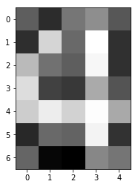

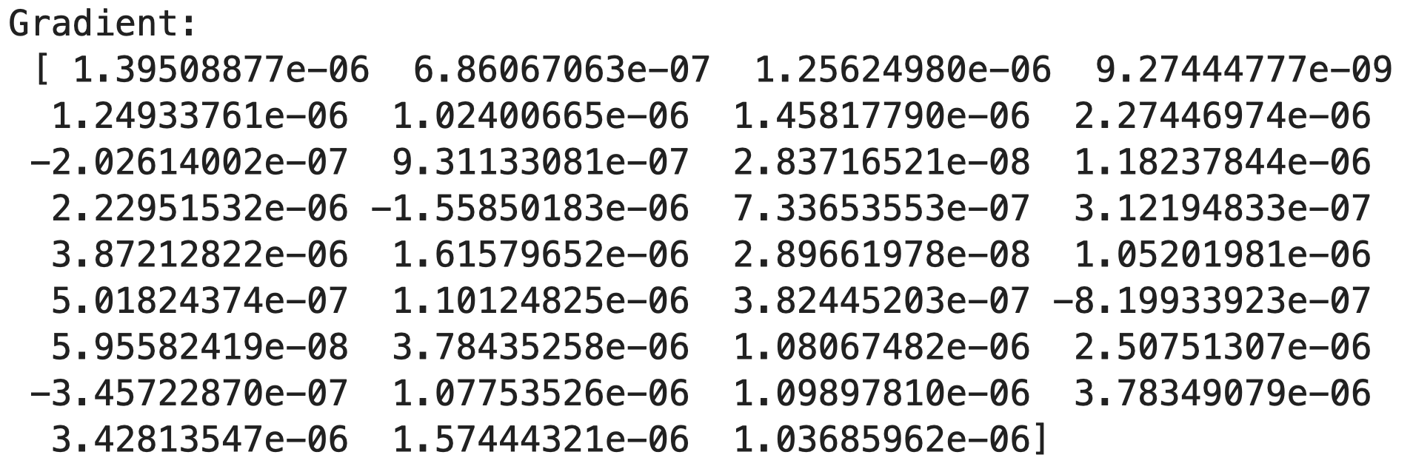

Solving with *Conjugate Gradient Descent* (CGM), Fletcher-Reeves variant without restart condition yields a result in 15 iterations, which is really fast in comparison with *GM*:





Finally, we solve it using *Broyden-Fletcher-Goldfarb-Shanno* (BFGS): we finish in just 8 iterations, but the accuracy is a bit smaller (<100%) than in the first two methods:





**(a.1) Solving for target = [4]**

Now that we are ready – having the objective function $L\left(X^{TR},y^{TR} \right)$, the first-derivative optimization algorithms which we have implemented during this course (GM, CGM and BFGS), and the data sets $X^{TR},y^{TR}$ and $X^{TE},y^{TE}$– we can solve the pattern recognition problem for any set of digits. We are going to start with the target set [4]. The training data set for this problem:

* Has 500 observations (p = 500).
* Train frequency = 0.5
* Noise frequency = 0.1

The hyperparameters for optimization defined for this problem are the following:

* $λ$ = 0.0 (no regularization).
* $ε$ = 1.0e–0.6
* $k^{max}$ = 1000 (iterations).

The hyperparameters for *line search*:

* $α_{0}^{max}=1$ initially. Later on, we update it by $α_{k}^{max}=\frac{2\left(f^{k}-f^{k-1}\right)}{∇f^{k^{T}}∙d^{k}}$.
* $c_{1}$ = 0.01
* $c_{2}$ = 0.45
* $ε$ = 1.0e–0.6
* $k^{max}$ = 500.

First, we use the *Gradient Descent* (GM) algorithm to minimize the loss function in the neural network.

|  |
| --- |
| $X^{TR}$, $X^{TE}$, $y^{TR}$, $y^{TE}$ =  gen_data(123456, 500,  [4], 0.5, 0.1)  net = SLNN()  net.train("GM", $X^{TR}$, $y^{TR}$)  net.summary($X^{TE}$, $y^{TE}$) |

The output (300 iterations):



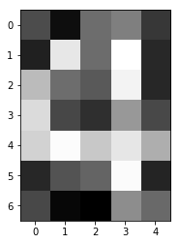



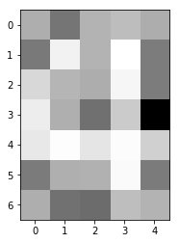

* = 0.0 (no regularization).
* $ε$ = 1.0e–0.6
* $k^{max}$ = 1000 (iterations).

The hyperparameters for *line search*:

* $α_{0}^{max}=1$ initially. Later on, we update it by $α_{k}^{max}=\frac{2\left(f^{k}-f^{k-1}\right)}{∇f^{k^{T}}∙d^{k}}$.
* $c_{1}$ = 0.01
* $c_{2}$ = 0.45
* $ε$ = 1.0e–0.6
* $k^{max}$ = 500.

Using GM, we reach $k^{max}$ = 1000:





In contrast, *CGM* *Fletcher-Reeves* variant without restart reaches a local optimum in 328 iterations:





Note that in all the executions we have used initial weights equal to *zero*. We first tried to sample them from a *Normal distribution* with zero mean, but it gave much worse results.

Let’s analyze the convergence of the three methods. All of them converge to a local optimum, since they achieved minimizing the loss function up to <0.0095 and the gradient norm <0.007 (*figure 3*).

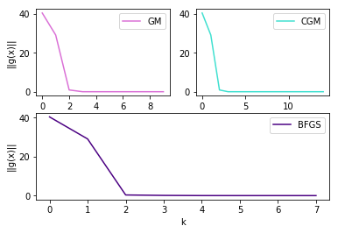

**Figure 3:** The decrease of the gradient norm.

The fastest one to converge is *BFGS*, but it is the less accurate from the three methods since its test accuracy is 99.96%, whereas training accuracy is 100%. The other two yield 100% training and test accuracy, which is actually really good – the neural network has learnt well the pattern with *GM* and *CGM*.

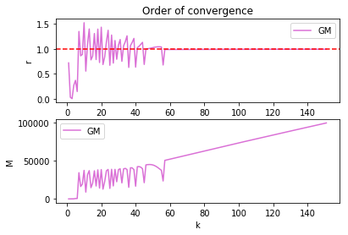

**Figure 4**: We have observed linear convergence in the Gradient Descent method, with rate = 1.

**(a.2) Solving for target = [8]**

Let’s solve now for the target set [8]. The training data set for this problem:

* Has 500 observations (p = 500).
* Train frequency = 0.5
* Noise frequency = 0.1

The hyperparameters for optimization defined for this problem are the following:



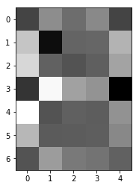

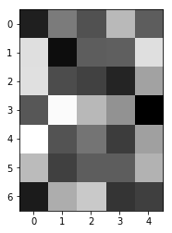

Output by *BFGS* is quite poor, it finishes its execution in 4 iterations without a decent loss minimization (we could improve that if we had added the regularization term):





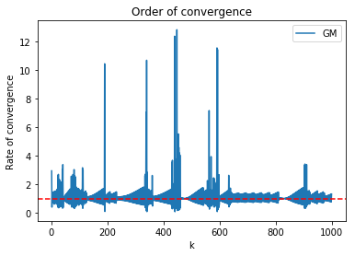

**Figure 5:** GM presents linear convergence with rate = 1.

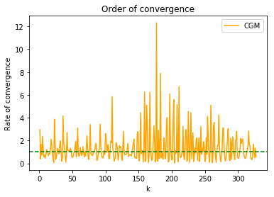

***Figure 6:*** *CGM rate of convergence with target set = [8].*

Again, the fastest method to finish is *BFGS*, but it does not find an optimum. *GM* does not find the minimum neither (it exceeds $k^{max}$). Thus, both of them yielded a <95% test accuracy, in case of *BFGS* <70% test accuracy. However, *CGM* does find a local minimum and outputs 100% train accuracy and quite a good test accuracy, 94.38%.

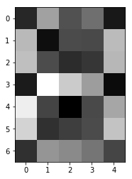

We can see in the matrix a group of numbers that share a high number of pixels between them: 0, 3, 8 and 9. These are also the numbers with the highest test accuracy!

If we sum the columns of the previous matrix (excluding the diagonal) we will get the sum of shared pixels with all other numbers:

[87, 41, 71, 85, 53, 77, 80, 47, 95, 90]

Sorting the numbers according to this, we get:

8, 9, 0, 3, 6, 5, 2, 4, 7, 1

While sorting according to the test accuracy (from lower to higher) we get:

8, 9, 0, 3, 6, 2, 7, 5, 1, 4

The first 5 digits with the most shared digits are also the ones with the lowest test accuracy. There seems to be an obvious relationship between the shared pixels and the accuracy of our one-digit models.

**(b) BFGS for all digits one by one**

We use the SLNN to identify each single number from 0 to 9. We use a training set of size 500, and the results can be reproduced with the *123456* seed. After training, we get the following results:

|  |  |  |  |
| --- | --- | --- | --- |
|  | Iter. | train ACC. | test ACC. |
| 0 | 3 | 94.6% | 89.48% |
| 1 | 5 | 99.6% | 99.68% |
| 2 | 3 | 97.8% | 94.94% |
| 3 | 3 | 94.6% | 90.44% |
| 4 | 5 | 100.0% | 99.72% |
| 5 | 3 | 98.4% | 97.66% |
| 6 | 4 | 96.4% | 94.14% |
| 7 | 5 | 98.0% | 96.04% |
| 8 | 3 | 87.2% | 74.08% |
| 9 | 3 | 93.2% | 85.46% |

We can see how there are some numbers that have a much lower accuracy than the others. This can be explained easily: the SLNN only takes into account the position of the pixels, giving each of them higher weights if they are more important for identifying our target number. But here is the problem: other numbers also share those same pixels!

In the following matrix you can see the number of shared pixels of each pair of numbers:

|  |  |  |  |  |  |  |  |  |  |  |
| --- | --- | --- | --- | --- | --- | --- | --- | --- | --- | --- |
|  | 0 | 1 | 2 | 3 | 4 | 5 | 6 | 7 | 8 | 9 |
| 0 | 16 | 4 | 9 | 12 | 7 | 12 | 11 | 5 | 14 | 13 |
| 1 | 4 | 10 | 5 | 5 | 4 | 5 | 6 | 2 | 5 | 5 |
| 2 | 9 | 5 | 14 | 10 | 5 | 7 | 6 | 9 | 10 | 10 |
| 3 | 12 | 5 | 10 | 14 | 5 | 10 | 10 | 6 | 14 | 13 |
| 4 | 7 | 4 | 5 | 5 | 15 | 6 | 9 | 4 | 7 | 6 |
| 5 | 12 | 5 | 7 | 10 | 6 | 17 | 10 | 5 | 11 | 11 |
| 6 | 11 | 6 | 6 | 10 | 9 | 10 | 16 | 4 | 13 | 11 |
| 7 | 5 | 2 | 9 | 6 | 4 | 5 | 4 | 11 | 6 | 6 |
| 8 | 14 | 5 | 10 | 14 | 7 | 11 | 13 | 6 | 17 | 15 |
| 9 | 13 | 5 | 10 | 13 | 6 | 11 | 11 | 6 | 15 | 16 |

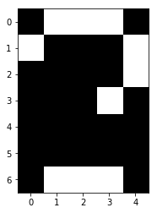 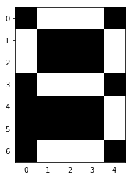 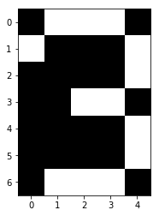

**Figure 7:** Shared pixels of (8, 2), (8, 9) and (3, 9).